Coding Systems (ASCII, Unicode and Parity)

# ASCII

ASCII uses 7 bits to store characters. Its main advantage is space efficiency, however it has a very limited character set – only English letters and some punctuation

# Unicode

Unicode uses more bits to store characters – the most common forms are Unicode-16 and Unicode-32. Whilst taking more space, Unicode allows for a much larger character set, allowing for other languages’ characters.

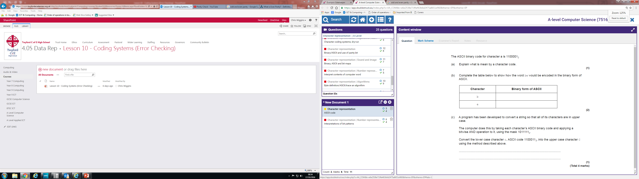

1011111

1100011

**1000011**

1100101

1100010

# Parity Bits

Parity bits are used to verify the integrity of binary values

* An **odd parity bit** is set to 1 if there is an *odd* number of 1s in the binary code
* An **even parity bit** is set to 1 if there is an *even* number of 1s in the binary code

|  |  |  |  |
| --- | --- | --- | --- |
| Binary Number | No. of 1s | Even Parity Bit | Odd Parity Bit |
| 0000 0000 | 0 | 0 | 1 |
| 1010 1101 | 5 | 1 | 0 |
| 1100 1010 | 4 | 0 | 1 |

<

# Majority Voting

Each bit is tripled (1001🡪 111000000111). The most common bit of each triplet is assumed to be correct. This allows correction for up to one corrupted bit in every 3 bits.

# Check Digits

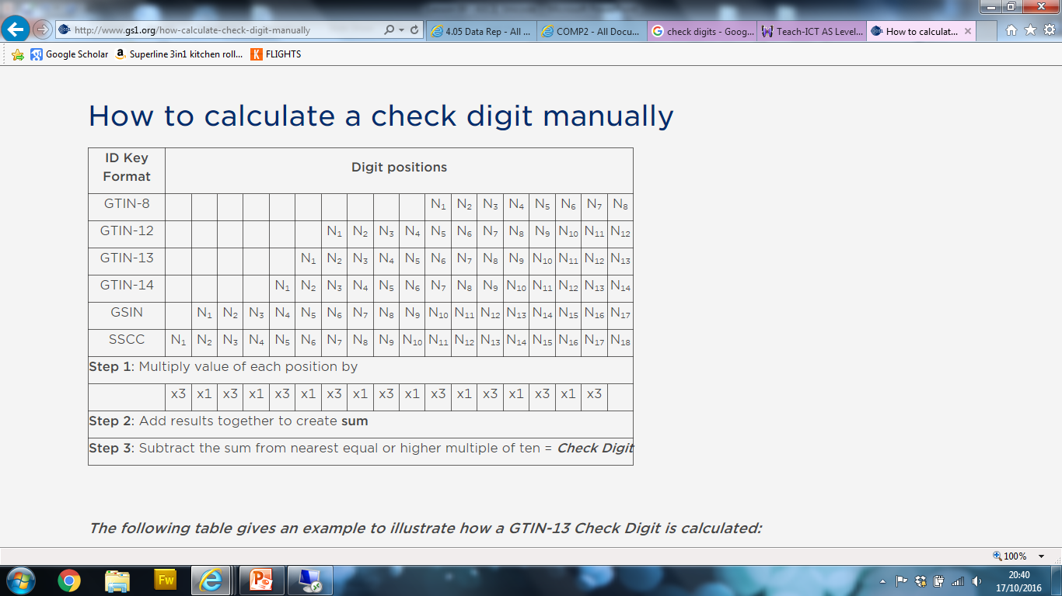Check digits combine the digits of a number in a certain way to ascertain a value that can be used to check its validity, such as a recursive digital root (15234 🡪 15 🡪 6)